COMP 4981

Assignment 1

Testing

Wilson Sue & Roy Xavier Pimentel

A01266055 & A00697839

Feb 4th, 2024

**Features 3**

Connection Handling 3

Receiving GET, HEAD, POST requests 3

Processing GET, HEAD, POST requests 3

Database Integration 3

**Test Results 4**

General Usage 4

**Stress Testing 6**

Examples found below 6

**Examples 7**

Browser Compatibility Test Part 1 | Multi Browser connected: 7

Browser Compatibility Test Part 2: 8

Multi-Client disconnect 9

Multi Post connected 9

# 

# Features

## Connection Handling

The server accepts incoming connections using accept(). It can handle multiple clients simultaneously up to a defined limit (MAX_CLIENTS).

## Receiving GET, HEAD, POST requests

The server reads data sent by clients into a buffer and processes it based on the request type. It specifically looks for "GET", "POST", and "HEAD" requests to determine how to respond.

## Processing GET, HEAD, POST requests

When a GET request is detected, the server retrieves the requested file from the specified webroot directory and sends it back to the client. If the requested file is not found, the server attempts to open a 404.html file to inform the client that the requested resource could not be found.

For "POST" requests, particularly to the "/submit" path, the server parses the body of the request to process the data sent by clients. It demonstrates basic handling of content length and body data extraction.

## Database Integration

* Within the POST branch, there's an attempt to interact with a database using openDatabase
* POST data is extracted
* Using the POST data storeStringInDB that overwrites the data while attaching a generic key
* Then readStringFromDB is called to read that string and attach it to the response

For "HEAD" requests, it attempts to provide headers similar to a "GET" request but without the body content, suitable for clients that need resource metadata without transferring the resource itself.

# 

# Test Results

## General Usage

| **Command** | **Purpose** | **Status** |
| --- | --- | --- |
| [START SERVER](https://docs.google.com/document/d/1pHwipGddB6WWkPm9lbRW_rFzK_LCv2s6vCd4rXuHNLQ/edit#heading=h.tsfllnkzvyhq)(link) | | |
| ./server | This defaults to localhost:8080 | Passed |
| ./server <server_IP> <PORT> | Initializes and starts server to specified IP and PORT | Passed |
| [GET request from Browser](https://docs.google.com/document/d/1pHwipGddB6WWkPm9lbRW_rFzK_LCv2s6vCd4rXuHNLQ/edit#heading=h.6j3sd9g7flzw)(link) | | |
| FROM BROWSER:  <server_IP>:<PORT> | To handle a GET request input which redirects to index.html | Passed |
| <server_IP>:<PORT>/index.html | To handle a GET request to reach the homepage | Passed |
| <server_IP>:<PORT> / <HTMLfile> | To handle a GET request and access an explicit HTML added to webroot | Passed |
| 127.0.0.1:8080 OR http://localhost:8080/ | Input url on browser if default ./server was run | Passed |
| [GET from curl](https://docs.google.com/document/d/1pHwipGddB6WWkPm9lbRW_rFzK_LCv2s6vCd4rXuHNLQ/edit#heading=h.oqkaf0i6jfx6)(link) | | |
| curl -0 http://localhost:8080 | Runs a POST request from terminal for localhost | Passed |
| curl -0 <server_IP> : <PORT> | Runs a POST request from terminal for server_IP | Passed |
| GET from wget | | Passed |
| wget <server_IP>:<PORT> | Get command to go to the homepage | Passed |
| [POST with curl](https://docs.google.com/document/d/1pHwipGddB6WWkPm9lbRW_rFzK_LCv2s6vCd4rXuHNLQ/edit#heading=h.gdvb0hw97h23)(link) | | |
| curl -X POST localhost:8080/submit -d "String"  OR  curl -X POST 127.0.0.1:8080/submit -d "String" | POST request with localhost | Passed |
| curl -X POST <server_IP>:<PORT>/submit -d "String" | POST request with server_IP | Passed |
| [POST with wget](https://docs.google.com/document/d/1pHwipGddB6WWkPm9lbRW_rFzK_LCv2s6vCd4rXuHNLQ/edit#heading=h.6324wjudt09g)(link) | |  |
| wget --post-data "String" localhost:8080/submit  OR  wget --post-data "String" 127.0.0.1:8080/submit | POST request with localhost | Passed |
| wget --post-data "String" <server_IP>:<PORT>/submit | Post request with server_IP | Passed |
| [HEAD with curl and wget](https://docs.google.com/document/d/1pHwipGddB6WWkPm9lbRW_rFzK_LCv2s6vCd4rXuHNLQ/edit#heading=h.i0gxvmke0d8s)(link) | |  |
| curl -I <server_IP>:<PORT>/index.html | HEAD Request with curl | Passed |
| wget --spider --server-response <server_IP>:<PORT>/index.html | HEAD Request with wget | Passed |
| [Quitting Server or client](https://docs.google.com/document/d/1pHwipGddB6WWkPm9lbRW_rFzK_LCv2s6vCd4rXuHNLQ/edit#heading=h.m0rbi6x3og6v)(link) | | |
| ctrl-c | Quit from either any Client or Server connection | Passed |

# 

# Stress Testing(NOT DONE LAST PART)

## Examples found below

| **Test Case** | **Purpose** | **Status** | **Example** |
| --- | --- | --- | --- |
| Browser Compatablitiy Test:   1. Chrome 2. Brave 3. Opera 4. Chromium 5. Edge   Extra tests   1. Edge mobile   (android/ios)   1. Chrome mobile   (android) | Testing compatibility of GET calls from multiple browsers | passed | Link |
| Multi Browser connected | Test Multiple browsers can connect via get and stay on | passed | Link |
| Multi-Client disconnect | Test Multiple browsers connected can disconnect gracefully even in random order of disconnect | passed | Link |
| Multi Post connected | Testing variable length and string test case for multiple posts sent to the same server. Make sure db contents overwritten | passed | Link |
| Multi OS test  Ubuntu  Manjaro  Fedora | Test if server.c can compile and run in different operating systems | passed | Link |
| Subdirectory access: |  |  |  |

# 

# 

# Examples

### Browser Compatibility Test Part 1 | Multi Browser connected | Ubuntu:

In order : Brave | Opera | Chromium | Chrome

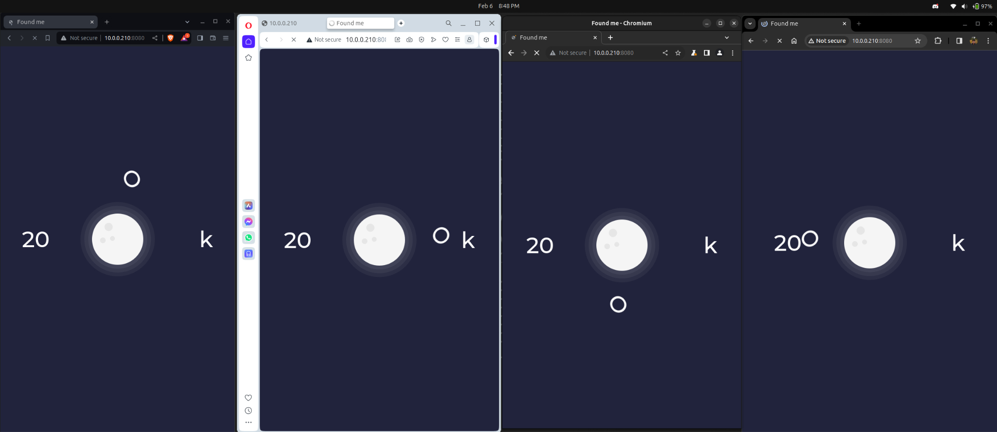

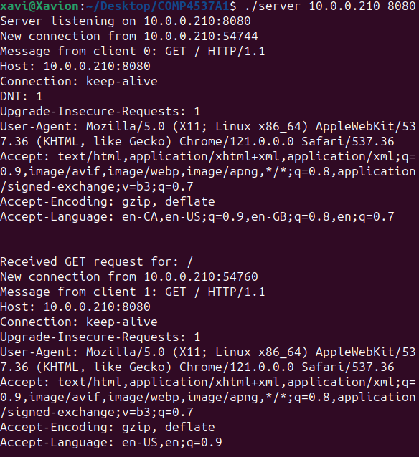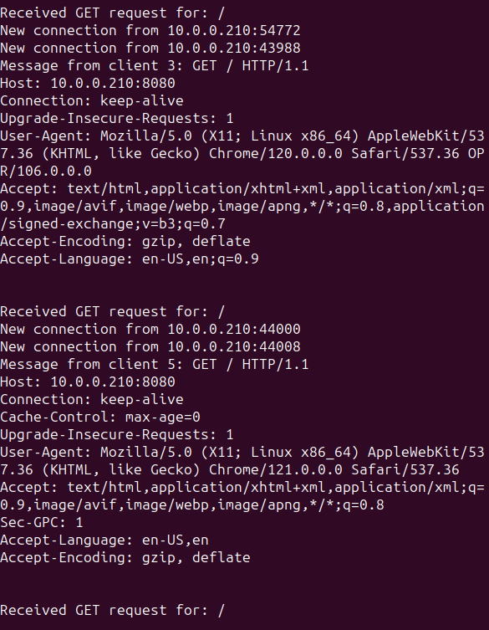

### Browser Compatibility Test Part 2:

Edge

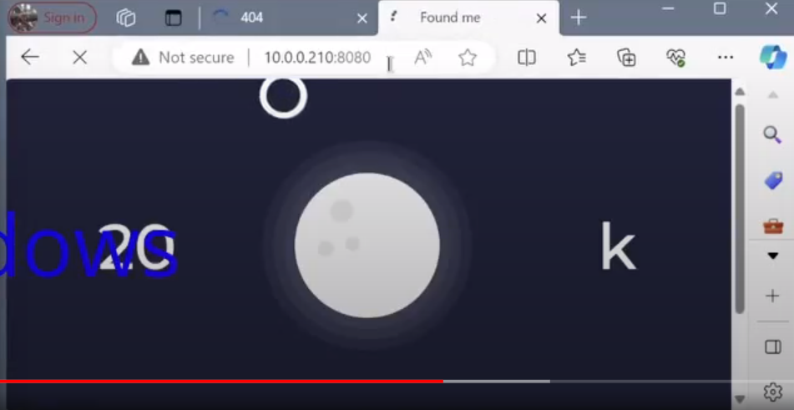

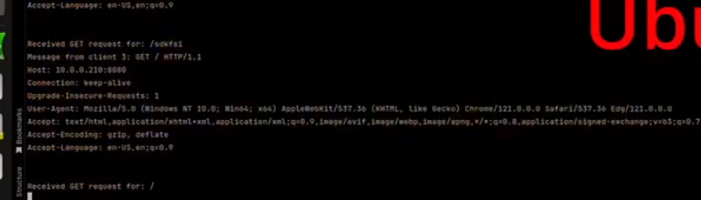

### Multi-Client disconnect

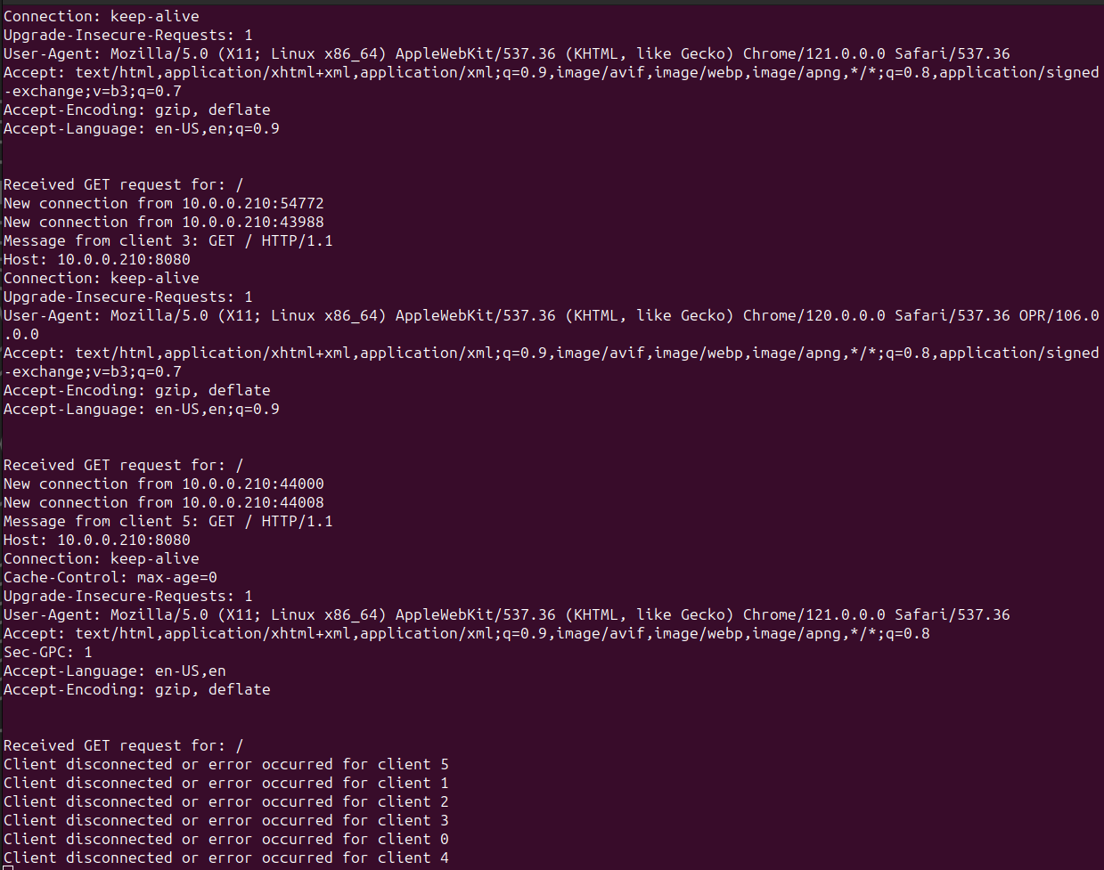

### Multi Post connected

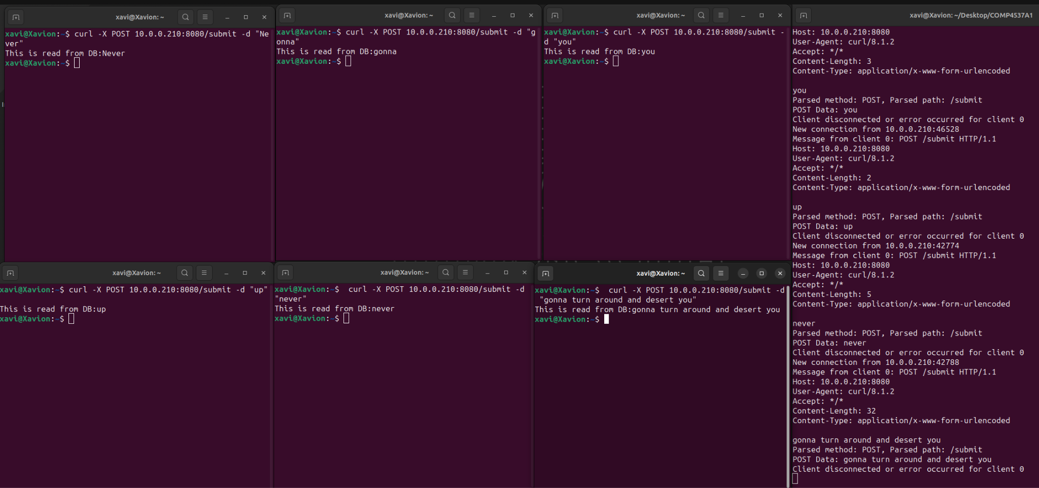

### Multi OS

